WESTERN PACIFIC UNIVERSITY
CMN224 / CMP224 Software Engineering — Week 9
Lab 6: Behavioural Diagrams for Your Client
Formative (ungraded) · Moodle-enabled · completes the modelling half of Task 4 (15%, due Week 11)
Item | Details
Linked to | Week 9 lecture — Behavioural UML and the 4+1 view model (ULO2, ULO4)
Work mode | Individually, on the SAME client you used for Task 2 and Lab 4
Time | About 90 minutes
Tools | diagrams.net desktop OR PlantUML — free, offline, both cached on Moodle
Submission | Four diagrams + this worksheet to Moodle AND committed to week09/ in your portfolio
This finishes Task 4. Task 4 (Design & Modelling Deliverable, due Week 11) asks for a use-case model, a class diagram, state and activity diagrams, an outline architecture and one applied design pattern. Lab 4 gave you the architecture. Today gives you the four diagrams. Week 13–14 supplies the pattern.
Part A — Use case diagram (20 min)
Show the actors, the system boundary and 5–9 use cases. Each use case is a goal in the actor's language, not a screen or a button.
# | Check before you move on | Done
1 | Every actor is a ROLE, not a named person
2 | Every use case is a goal (a verb phrase the client would recognise)
3 | The system boundary is drawn — it is clear what is outside
4 | Every use case traces to a user requirement in your SRS
PlantUML starter
@startuml
left to right direction
actor Bursar
actor "Head teacher" as Head
rectangle "Fee System" {
Bursar --> (Record payment)
Bursar --> (Issue receipt)
Head --> (Approve refund)
}
@enduml
Figure 1: Use Case Diagram for the Fee Payment System
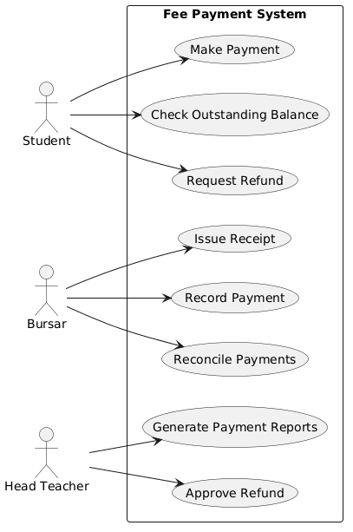
Part B — Class diagram (25 min)
Show 4–7 classes with attributes, key operations, named associations and multiplicity. Read your SRS: recurring nouns are candidate classes.
# | Check before you move on | Done
1 | Every association is NAMED (pays, generates, approves)
2 | Multiplicity is shown at both ends
3 | At least one multiplicity encodes a real business rule from Week 2
4 | No attribute exists that your SRS never mentions
PlantUML starter
@startuml
class Student {
- studentId
- termFee
+ outstandingBalance()
}
class Payment {
- amount
- method
}
Student "1" -- "0..*" Payment : pays
@enduml
Figure 2: Class Diagram for the Fee Payment System
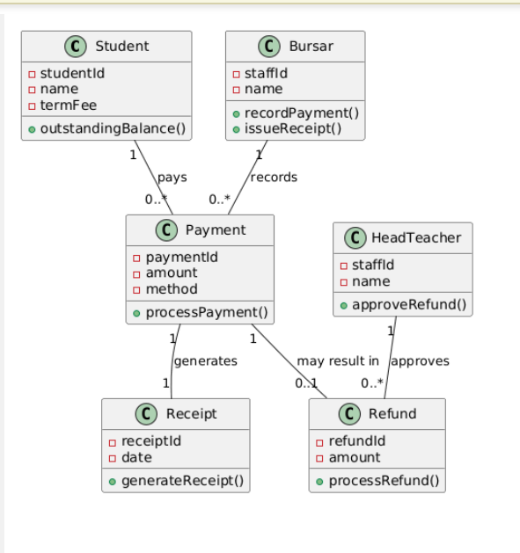
Part C — State diagram (20 min)
Pick ONE thing in your system that has a genuine lifecycle — a payment, an intake record, an application. Show its states, the triggers between them, and at least one guard.
# | Check before you move on | Done
1 | Every state is a CONDITION, not an action
2 | Every transition names its trigger
3 | At least one guard [in brackets] encodes a business rule
4 | There is a start state and at least one end state
PlantUML starter
@startuml
[*] --> Recorded : record
Recorded --> Receipted : print
Receipted --> Reconciled : match
Reconciled --> Refunded : [head teacher approves]
Reconciled --> [*]
@enduml
Figure 3: State Diagram for a Payment Transaction
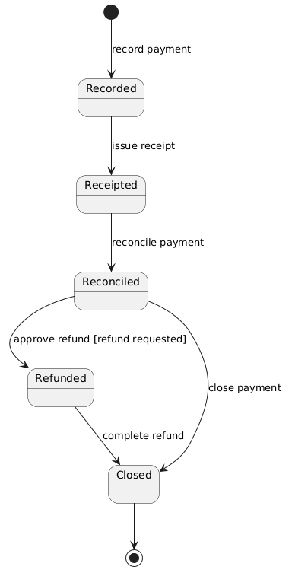
Part D — Activity diagram with swimlanes (20 min)
Model one workflow that crosses a boundary in your Week 5 deployment diagram. It must include a branch for what happens when the network or power is unavailable.
# | Check before you move on | Done
1 | Swimlanes match the devices/roles in my deployment diagram
2 | There is a decision node for the offline case
3 | The workflow shows what staff can still do while the link is down
4 | Duplicate-safe handling appears where data is imported
PlantUML starter
@startuml
|Depot laptop|
start
:Record intake;
:Queue change;
if (signal available?) then (yes)
:Send batch;
|Town office|
:Import, skip duplicates;
else (no)
:Hold in queue;
endif
stop
@enduml
Figure 4: Activity Diagram for Payment Processing and Synchronisation
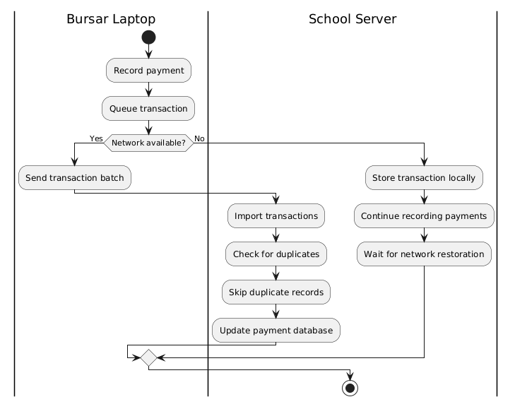
Part E — Commit (5 min)
- Save all four diagram files into week09/ in your portfolio.
git add week09/
git commit -m "Add use case, class, state and activity diagrams"
AI use: you may generate PlantUML drafts, but you must validate every diagram against your own SRS using the five checks from the lecture. Generated models routinely omit the offline branch and the approval chain — the two things that matter most here. Declare AI use in your README.

AI Use Declaration
- I used Microsoft Copilot to help generate the initial PlantUML diagrams for this lab. However, I have reviewed and confirmed each diagram against my own System Requirements Specification (SRS) and the diagram checklist specified in the lecture files. I ensured that all actors, lessons, states, sports, relationships, and corporate policies closely considered the necessities of the Fee Payment System. Attention was given to including the offline workflow and the refund approval process, as these are important system requirements that are sometimes omitted in AI-generated models. The final diagrams were checked, corrected where necessary, and are my own validated work.

